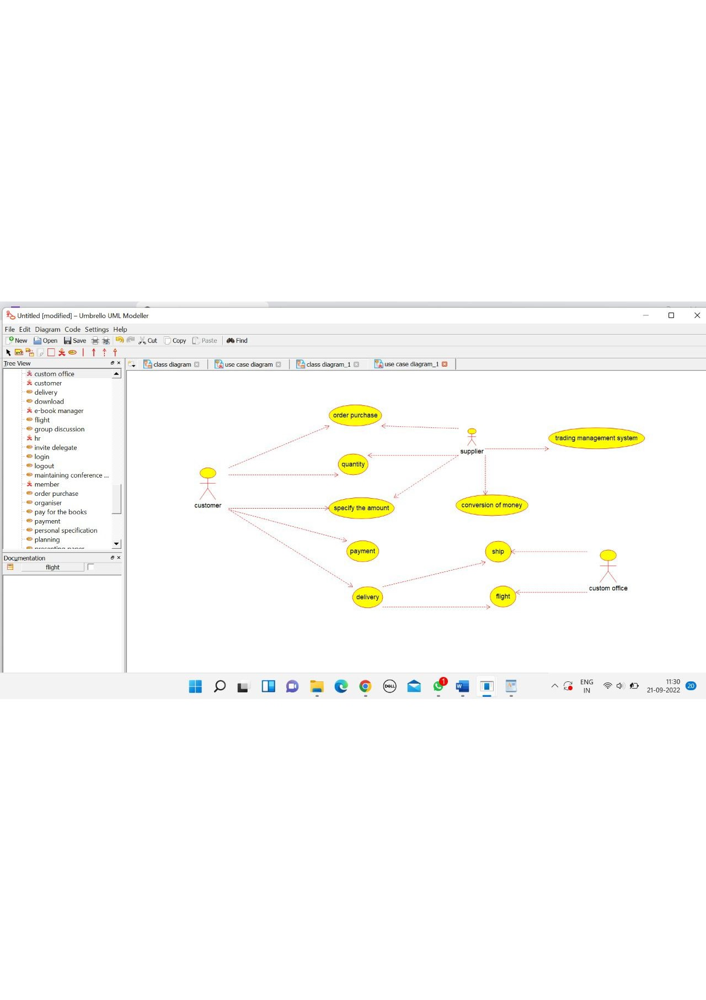

TRADING MANAGEMENT SYSTEM

/**

* Class trading_management_system

*/

public class trading_management_system {

//

// Fields

//

private void verify_product;

private void amount;

//

// Constructors

//

public trading_management_system () { };

//

// Methods

//

//

// Accessor methods

//

/**

* Set the value of verify_product

* @param newVar the new value of verify_product

*/

private void setVerify_product (void newVar) {

verify_product = newVar;

}

/**

* Get the value of verify_product

* @return the value of verify_product

*/

private void getVerify_product () {

return verify_product;

}

/**

* Set the value of amount

* @param newVar the new value of amount

*/

private void setAmount (void newVar) {

amount = newVar;

}

/**

* Get the value of amount

* @return the value of amount

*/

private void getAmount () {

return amount;

}

//

// Other methods

//

/**

*/

public void transport()

{

}

/**

*/

public void delivery_product()

{

}

/**

*/

public void money_transfer()

{

}

}

SUPPLIER

/**

* Class supplier

*/

public class supplier {

//

// Fields

//

private void product_supply;

//

// Constructors

//

public supplier () { };

//

// Methods

//

//

// Accessor methods

//

/**

* Set the value of product_supply

* @param newVar the new value of product_supply

*/

private void setProduct_supply (void newVar) {

product_supply = newVar;

}

/**

* Get the value of product_supply

* @return the value of product_supply

*/

private void getProduct_supply () {

return product_supply;

}

//

// Other methods

//

/**

*/

public void available_product()

{

}

/**

*/

public void money_transfer()

{

}

}

CUSTOMER

/**

* Class customerr

*/

public class customerr {

//

// Fields

//

private void order_product;

private void quality;

//

// Constructors

//

public customerr () { };

//

// Methods

//

//

// Accessor methods

//

/**

* Set the value of order_product

* @param newVar the new value of order_product

*/

private void setOrder_product (void newVar) {

order_product = newVar;

}

/**

* Get the value of order_product

* @return the value of order_product

*/

private void getOrder_product () {

return order_product;

}

/**

* Set the value of quality

* @param newVar the new value of quality

*/

private void setQuality (void newVar) {

quality = newVar;

}

/**

* Get the value of quality

* @return the value of quality

*/

private void getQuality () {

return quality;

}

//

// Other methods

//

/**

*/

public void payment()

{

}

/**

*/

public void deliver()

{

}

/**

*/

public void transport()

{

}

}

